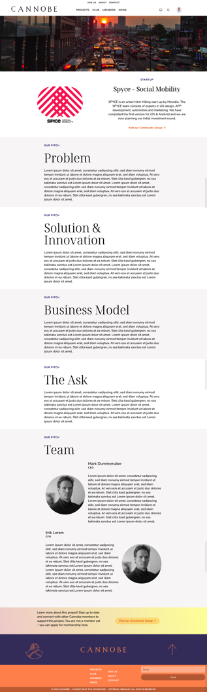

Content Template for Cannobe featured Project and Startup Page

Cover Image

Please provide a JPG for your cover image with max. 5 MB size and min. width of 1440 x 740 px. If you are not able to crop it we will do it for you but please it should be have a minimum width of 1440. Please send us the JPG as file and not (only) embedded in this document

Logo

Please provide your Logo in a png or jpg format the width should be min. 300 px. Please send us the attached file via mail and not (only) the embed in this document.

Startup / Project Name

What is the Name of your project / Startup?
Please add Website, Social Account Links … please fill in:

What is it about?

Please fill in a short description about your Project / Startup in 250 characters.

Lorem ipsum dolor sit amet, consetetur sadipscing elitr, sed diam nonumy eirmod tempor invidunt ut labore et dolore magna aliquyam erat, sed diam voluptua. At vero eos et accusam et justo duo dolores et ea rebum. Stet clita kasd gubergren, no sea tak

PITCH
Problem

Please describe the problem you are solving or addressing with your project. What is the initial situation? What is the problem you’re going to solve? How big is the problem, and why should investors or supporters care? Max. 800 characters

Lorem ipsum dolor sit amet, consetetur sadipscing elitr, sed diam nonumy eirmod tempor invidunt ut labore et dolore magna aliquyam erat, sed diam voluptua. At vero eos et accusam et justo duo dolores et ea rebum. Stet clita kasd gubergren, no sea takimata sanctus est Lorem ipsum dolor sit amet. Lorem ipsum dolor sit amet, consetetur sadipscing elitr, sed diam nonumy eirmod tempor invidunt ut labore et dolore magna aliquyam erat, sed diam voluptua. At vero eos et accusam et justo duo dolores et ea rebum. Stet clita kasd gubergren, no sea takimata sanctus est Lorem ipsum dolor sit amet. Lorem ipsum dolor sit amet, consetetur sadipscing elitr, sed diam nonumy eirmod tempor invidunt ut labore et dolore magna aliquyam erat, sed diam voluptua. At vero eos et accusam et justo duo dolores et ea re

PITCH
Solution & Innovation

How is your product going to solve the problem? Make sure you clearly lay out the benefits of your solution. If you can, include three benefits that get the message across loud and clear. Max. 800 characters

Lorem ipsum dolor sit amet, consetetur sadipscing elitr, sed diam nonumy eirmod tempor invidunt ut labore et dolore magna aliquyam erat, sed diam voluptua. At vero eos et accusam et justo duo dolores et ea rebum. Stet clita kasd gubergren, no sea takimata sanctus est Lorem ipsum dolor sit amet. Lorem ipsum dolor sit amet, consetetur sadipscing elitr, sed diam nonumy eirmod tempor invidunt ut labore et dolore magna aliquyam erat, sed diam voluptua. At vero eos et accusam et justo duo dolores et ea rebum. Stet clita kasd gubergren, no sea takimata sanctus est Lorem ipsum dolor sit amet. Lorem ipsum dolor sit amet, consetetur sadipscing elitr, sed diam nonumy eirmod tempor invidunt ut labore et dolore magna aliquyam erat, sed diam voluptua. At vero eos et accusam et justo duo dolores et ea re

PITCH
Business Model

Investors want to be assured that they’re going to be able to make their money back, which means they are going to want to know exactly how you’re planning to earn revenue (and why this means investors are looking at getting a good return) Supporters want to be motivated and incentivised by your project and be convinced of the sense and permanence of the project. Max. 800 characters

Lorem ipsum dolor sit amet, consetetur sadipscing elitr, sed diam nonumy eirmod tempor invidunt ut labore et dolore magna aliquyam erat, sed diam voluptua. At vero eos et accusam et justo duo dolores et ea rebum. Stet clita kasd gubergren, no sea takimata sanctus est Lorem ipsum dolor sit amet. Lorem ipsum dolor sit amet, consetetur sadipscing elitr, sed diam nonumy eirmod tempor invidunt ut labore et dolore magna aliquyam erat, sed diam voluptua. At vero eos et accusam et justo duo dolores et ea rebum. Stet clita kasd gubergren, no sea takimata sanctus est Lorem ipsum dolor sit amet. Lorem ipsum dolor sit amet, consetetur sadipscing elitr, sed diam nonumy eirmod tempor invidunt ut labore et dolore magna aliquyam erat, sed diam voluptua. At vero eos et accusam et justo duo dolores et ea re

PITCH
The Aks

What is your startup looking for? Please describe what the funding you are looking for will be used for and what the following rounds will look like. Please keep in mind that our members can also be industry experts. Searching for experts can also open very interesting doors. Max. 800 characters

Lorem ipsum dolor sit amet, consetetur sadipscing elitr, sed diam nonumy eirmod tempor invidunt ut labore et dolore magna aliquyam erat, sed diam voluptua. At vero eos et accusam et justo duo dolores et ea rebum. Stet clita kasd gubergren, no sea takimata sanctus est Lorem ipsum dolor sit amet. Lorem ipsum dolor sit amet, consetetur sadipscing elitr, sed diam nonumy eirmod tempor invidunt ut labore et dolore magna aliquyam erat, sed diam voluptua. At vero eos et accusam et justo duo dolores et ea rebum.
PITCH
Team

Who is your team? What are they good at? And why are they going to help lead your business to success? Max. 500 characters per team member

Lorem ipsum dolor sit amet, consetetur sadipscing elitr, sed diam nonumy eirmod tempor invidunt ut labore et dolore magna aliquyam erat, sed diam voluptua. At vero eos et accusam et justo duo dolores et ea rebum. Stet clita kasd gubergren, no sea takimata sanctus est Lorem ipsum dolor sit amet. Lorem ipsum dolor sit amet, consetetur sadipscing elitr, sed diam nonumy eirmod tempor invidunt ut labore et dolore magna aliquyam erat, sed diam voluptua. At vero eos et accusam et justo duo dolores et ea rebum. Stet clita kasd gubergren, no sea takimata sanctus est Lorem ipsum dolor sit amet. Lorem ipsum dolor sit amet, consetetur sadipscing elitr, sed diam nonumy eirmod tempor invidunt ut labore et dolore magna aliquyam erat, sed diam voluptua. At vero eos et accusam et justo duo dolores et ea re

Team photos

Please send us one photo per team member. All photos should have a similar background and lightning – but most important they should be good. Min size 260 x 260 px. Max size 5 MB. We will crop the image to a square and set a circle mask.

Please describe briefly why the team member in question is suitable for your task. It should not be a vitae but rather a short introduction that refers to experiences and interests.

Full Name:
Position / Role:
LinkedIn Account:

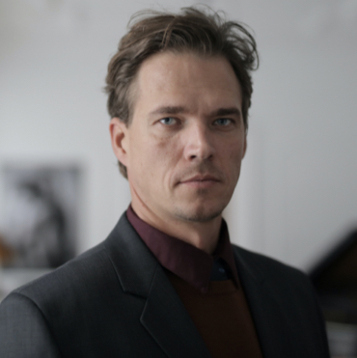

Lorem ipsum dolor sit amet, consetetur sadipscing elitr, sed diam nonumy eirmod tempor invidunt ut labore et dolore magna aliquyam erat, sed diam voluptua. At vero eos et accusam et justo duo dolores et ea rebum. Stet clita kasd gubergren, no sea takimata sanctus est Lorem ipsum dolor sit amet. Lorem ipsum dolor sit amet, consetetur sadipscing elitr, sed diam nonumy eirmod tempor invidunt ut labore et dolore magna aliquyam erat, sed diam voluptua. At vero eos et accusam et justo duo dolores et ea rebum. Stet clita kasd gubergren, no sea takimata sanctus est Lorem ipsum dolor sit amet. Lorem ipsum dolor sit amet, consetetur sadipscing elitr, sed diam nonumy eirmod tempor invidunt ut labore et dolore magna aliquyam erat, sed diam voluptua.

Full Name:
Position / Role:
LinkedIn Account:

Lorem ipsum dolor sit amet, consetetur sadipscing elitr, sed diam nonumy eirmod tempor invidunt ut labore et dolore magna aliquyam erat, sed diam voluptua. At vero eos et accusam et justo duo dolores et ea rebum. Stet clita kasd gubergren, no sea takimata sanctus est Lorem ipsum dolor sit amet. Lorem ipsum dolor sit amet, consetetur sadipscing elitr, sed diam nonumy eirmod tempor invidunt ut labore et dolore magna aliquyam erat, sed diam voluptua. At vero eos et accusam et justo duo dolores et ea rebum. Stet clita kasd gubergren, no sea takimata sanctus est Lorem ipsum dolor sit amet. Lorem ipsum dolor sit amet, consetetur sadipscing elitr, sed diam nonumy eirmod tempor invidunt ut labore et dolore magna aliquyam erat, sed diam voluptua.

Please copy as much as needed.

Send this application and the logo and images to ulf.leonhard@cannobe.com

Thank you!

